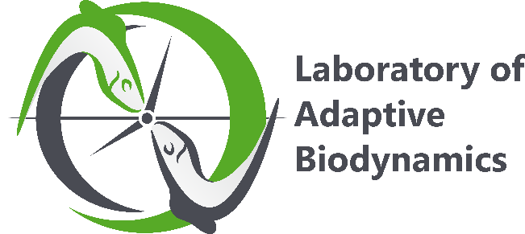

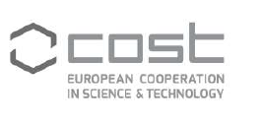


www.onehealthdrugs.com

Crash course in ecotoxicology: From concepts to practice
Wednesday 27 May – Friday 29 May 2026
University of Namur, Namur, Belgium

Training School of the COST Action CA21111
One Health drugs against parasitic vector borne diseases in Europe and beyond
OneHealthdrugs

The event is open to PhD, young innovators and senior scientists from both academia and pharma

Description. This 3-day training school will introduce early-career researchers, Ph.D. students, and postdoctoral fellows to the fundamentals of ecotoxicology. Through a combination of lectures, interactive sessions featuring case studies, and hands-on laboratory work, participants will explore how chemicals affect organisms and the ecosystems they inhabit. The participants will gain an overview of the main classes of chemical pollutants, how these substances enter and move through the environment, the effects they can have on wildlife, and approaches to measuring and mitigating their impact. The program will also cover the principles of dose–response testing, experimental design, and data interpretation, and will include a practical session running a standard toxicity assay. Emphasis will be placed on linking laboratory findings to ecological relevance and environmental safety. The course is designed for participants with no prior background in ecotoxicology and is open to trainees from a wide range of disciplines.

Preliminary Program

Day 1 (Wednesday 27 May 2026)
9:00 – 9:30 | Registration
9:30 – 10:00 | Welcome remarks (Prof. P. Costi) and introduction (Prof. E. Thoré)
10:00 – 10:30 | Lecture 1: When chemistry becomes contamination (Prof. E. Thoré)
10:30 – 11:00 | Lecture 2: When contamination becomes pollution (Prof. E. Thoré)
11:00 – 11:15 | Break
11:15 – 12:15 | Lecture 3: Ecotoxicology to understand consequences (Prof. E. Thoré)
12:15 – 13:15 | Lunch
13:15 – 14:15 | Lecture 4: Risk assessment and management (Prof. E. Thoré)
14:15 – 14:30 | Break
14:30 – 17:00 | Hands-on laboratory work: Acute toxicity testing
17:00 – 17:15 | Closing of day 1
Evening | Optional group dinner
Day 2 (Thursday 28 May 2026)
9:00 – 10:00 | Lecture 5: Frontiers in ecotoxicology (Prof. E. Thoré)
10:00 – 11:00 | Interactive discussion session (Prof. B. Reid)
11:00 – 11:15 | Break
11:15 – 12:15 | Expert talk: pharmaceutical pollution and wildlife behavior (Prof. M. Bertram, To Be Confirmed)
12:15 – 13:15 | Lunch
13:15 – 14:15 | Flash research talks (N. Goede, T. Kimario, N. Buratto, Dr. O. Missawi)
14:15 – 14:30 | Break
14:30 – 15:00 | Expert talk: Microbiome ecotoxicology (Dr. C. Theys)
15:00 – 15:30 | Expert talk: Evolutionary ecotoxicology (Dr. R. Almeida)
15:30 – 16:00 | Expert talk: Experimental methods in pre-clinical drug discovery (Dr. S. Gul)
16:00 – 17:00 | Hands-on laboratory work: Acute toxicity testing
17:00 – 17:15 | Close of day 2
Day 3 (Friday 29 May 2026)
9:00 – 9:30 | Expert talk: Delayed and transgenerational effects (Prof. F. Silvestre)
9:30 – 10:00 | Expert talk: Mixed stressor impacts on ecological communities (Prof. F. De Laender)
10:00 – 10:45 | Expert talk: Title to be Confirmed (Speaker To Be Confirmed)
10:45 – 11:00 | Group photo
11:00 – 11:15 | Break
11:15 – 12:15 | Participant flash presentations
12:15 – 13:15 | Lunch
13:15 – 13:45 | Expert talk: One Health Drugs (Prof. P. Costi)
13:45 – 14:15 | Expert talk: Biological and chemical properties of drugs (Dr. S. Gul)
14:15 – 14:30 | Break
14:30 – 16:30 | Hands-on laboratory work: Data analysis and interpretation
16:30 – 17:00 | Participant presentations of laboratory results
17:00 – 17:15 | Closing remarks
Successful applicants will need to create an e-COST account ( https://e-services.cost.eu) and will receive an official invitation to the Training School.
Please review the information below relating to data protection and online privacy:
https://europa.eu/youreurope/citizens/consumers/internet-telecoms/data-protection-online-privacy/index_en.htm

