AGENDA
“Success stories and challenges in OneHealth drug discovery for VBPD”
(remote HG4 + WG1–2–3–4)
May 18, 2026, from 10:00 to 13:00 CET

This workshop will provide a state-of-the-art overview and help define a collaborative, multidisciplinary roadmap within COST Action CA21111 across all career stages.

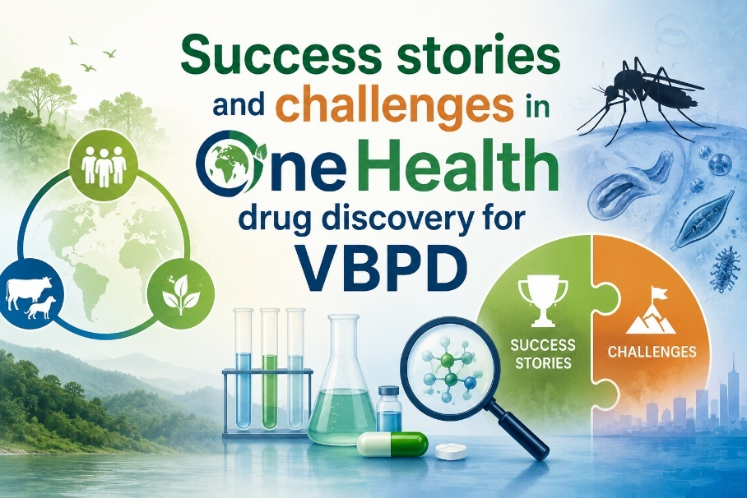

This workshop will bring together senior and early-career members to highlight success stories and challenges in One Health drug discovery strategies for vector-borne parasitic diseases, encountered in both scientific and communication activities across the network.

Registration link: Here is the Google Form link to register: https://docs.google.com/forms/d/e/1FAIpQLScph1TMmdneLVG40cDjG04NPDGWbknM2eKL2njg-ajyA8l7Bg/viewform?usp=header

May 18, 2026, from 10:00 to 13:00 CET

10:00 – 10:15 Welcome and introduction

10:15 – 10:35 Prof. Anabela Cordeiro Silva- I3S and Faculty of Pharmacy, University of Porto
Blended Intensive Program (BIP) on Drug Resistance in Cancer and Infectious Diseases

10:35 – 10:55 Dr Clara Lima - I3S and Faculty of Pharmacy, University of Porto
Tbd

10:55 – 11:15: Dr. Gulsah Bayraktar - Department of Pharmaceutical Chemistry, Ege University, Turkey
Development of Novel Thiazolopyrimidine Derivatives Active Against Visceral and Cutaneous Leishmania

11:15 – 11:35 Dr. Elisa Uliassi - Department of Pharmacy and Biotechnology, University of Bologna
My Journey in the OneHealthDrugs COST Action: Personal Experiences and Perspectives

10’ BREAK

11:45 – 12:05: Dr Daniele Aiello - Department of Life Sciences, University of Modena and Reggio Emilia
Computational Investigation of Xanthine-Based Inhibitors Targeting Trypanosomatid Pteridine Reductase 1

12:05 – 12.20: Aurora Gaza - - Department of Pharmacy and Biotechnology, University of Bologna (STSM at the School of Infection and Immunity, University of Glasgow)
Biological evaluation of small-molecule hydrophobic degraders for antiparasitic drug discovery and chemical biology applications

12:20 – 12.35: Dr Bianca Martinengo- - Department of Pharmacy and Biotechnology, University of Bologna
Unlocking Biocatalytic Oxidative Systems for the Sustainable Synthesis of Pharmaceuticals from Food Waste

12:40 Open discussion and reflections

Conclusions and way forward

Organized by Elisa Uliassi (IT, HG4 Leader), Maria Paola Costi (Action Chair), Anabela Cordeiro Silva (Action Vice-Chair)

