To be used to final conference organised by the Action.
To be sent to mariapaola.costi@unimore.it, cordeiro@ibmc.up.pt (cc piccolo@bm3s.com ) within a week from the meeting

One Health drugs against parasitic vector-borne diseases in Europe and beyond”
Date: 10 July 2026
Venue: COST Association, Brussels, Belgium

MINUTES
COST OneHealthDrugs MC12 meeting
10/7/2026; 09:00-17:00 (CET)
Prepared by Anabela Cordeiro-da-Silva, CA21111 Co-chair;
Federica Piccolo and Paola Costi, CA21111 Chair
- MEETING LINK
https://teams.microsoft.com/meet/334270686892993?p=080wGD2vOLkszVk6jN
Meeting ID: 334 270 686 892 993
Passcode: LC2Sv3W2

- LIST OF ATTENDANTS

CTRY * | Title | Firstname | Lastname | Group
Türkiye | Ms | Şerife Ezgi | Çetin
Switzerland | Dr | Annette | Ives | MC member; WG2 member; WG3 member; WG4 member; WG5 member
Greece | Prof | Elias | PAPADOPOULOS | WG3 member; WG5 member;WG6 member
Serbia | Ms | Nada | Milic | WG5 member
United Kingdom | Dr | Katrien | Van Bocxlaer | WG3 member
Azerbaijan | Ms | Gunel | Aliyeva | WG1 member; WG6 member
Tunisia | Dr | Hafidh | AKKARI | WG2 member; WG3 member
Italy | Prof | MARIA PAOLA | COSTI | MC chair; WG1 member; WG2 member; WG3 member; WG4 member; WG5 member;WG 6 member
Portugal | Prof | Anabela | Cordeiro-da-Silva | MC member; MC vicechair; WG2 member; WG3 member; WG5 member; WG6 member
Italy | Prof | Sandra | Gemma | LP; MC member; WG1 member; WG2 member; WG5 member; Horizontal Group 7 - Compounds degradability
France | Prof | Pascal | Marchand | WG1 member; WG4 member
Italy | Dr | Federica | Piccolo | WG1 member; WG2 member; WG3 member; WG4 member; WG5 member; WG6 member
Germany | Dr | Ulrike | Wittig | LP; WG leader; WG1 member; WG2 member; WG 3 member; WG4 member; WG5 member; WG6 member
Greece | Dr | Theodora | Calogeropoulou | MC member; WG leader; WG1 member; WG2 member; WG5 member
Belgium | Prof | Guy | Caljon | MC member; WG leader; WG3 member
Serbia | Dr | Biljana | Arsić | WG leader; WG1 member; WG2 member; WG3 member; WG4 member; WG5 member; WG6 member
Türkiye | Dr | Gülşah | Bayraktar | WG leader; WG2 member; WG5 member; Horizontal group 4 team - medicinal chemistry
United Kingdom | Prof | Harry | DE KONING | MC member; WG leader; WG 2 member; WG3 member; WG6 member
Greece | Mr | Theo | Zacharis | WG5 member; WG6 member
Greece | Dr | Ioannis | Papanastasiou | grant awarding coordinator; MC member; WG2 member
United Kingdom | Dr | Marco | Mazzorana | MC member; WG1 member; WG6 member
Germany | Prof | Paul | Selzer | MC member; WG2 member; WG3 member; WG5 member; Horizontal group 3 - Stakeholder involvement
Italy | Prof | Maria Laura | Bolognesi | MC member; WG1 member; WG2 member; WG5 member; WG6 member; Horizontal group 3 - Stakeholder involvement
Italy | Dr | Elisa | Uliassi | LP; WG1 member; WG5 member; Horizontal group 4 - Young Researchers and Innovators
Germany | Dr | Sheraz | Gul | LP; WG1 member; WG2 member; WG3 member; WG4 member; WG5 member; WG6 member; Horizontal group 5 - Training School management
Portugal | Dr | Bruno | Nunes | WG4 member
Portugal | Dr | Maria Alice | Carvalho | WG2 member
Portugal | Mr | André | Lopes
Italy | Dr | Valeria | Francesconi | WG1 member; WG5 member
Türkiye | Dr | Deniz | Ekinci | WG1 member; WG2 member; WG3 member; WG4 member; WG5 member; WG6 member
Belgium | Mr | Kayhan | Ilbeigi | WG3 member; WG5 member; Grant awarding Team participant- Ecotox-parasitology
Italy | Ms | Lori | Doko | WG2 member
Serbia | Dr | Pavle | Banovic | WG3 member; WG4 member
Türkiye | Dr | Huseyin | Istanbullu | WG1 member; WG2 member
Belgium | Dr | Wioleta | Walentowska | so action
Türkiye | Mr | Burak | KIRILMAZ | WG1 member; WG2 member; WG3 member; WG4 member; WG5 member; WG6 member
Türkiye | Ms | BILGE | TUZCU | WG1 member; WG2 member; WG3 member
Belgium | Dr | Thomas | Geurden
Slovenia | Dr | Marko | jukič | MC member; WG1 member
Italy | Dr | Asghar | Talbalaghi | WG2 member; WG5 member
Albania | Dr | Elton | Rogozi | MC member; WG2 member; WG5 member; WG6 member
France | Dr | Sumesh | Sasidharan | WG5 member; WG6 member
Kosovo* | Prof | Fatgzim | Latifi | WG1 member; WG3 member; WG6 member
Türkiye | Dr | Omer Gurkan | DILEK | WG1 member; WG2 member; WG3 member
Spain | Mr | Hafiz Muhammad | Safwan | WG1 member; WG2 member; WG3 member; WG4 member; WG5 member; WG6 member
Albania | Ms | Doloresa | Mullaliu | WG2 member; WG3 member; WG4 member; WG5 member; WG6 member
Bosnia & Herzegovina | Dr | Relja | Suručić | MC member; WG1 member; WG2 member; WG5 member
France | Dr | Sebastien | POMEL | MC member; WG3 member
Türkiye | Prof | Murat | Şentürk | WG1 member; WG2 member; WG3 member; WG4 member; WG5 member; WG6 member
North Macedonia | Prof | Dijana | Blazhekovikj - Dimovska | WG1 member; WG2 member; WG4 member; WG5 member; WG6 member
Serbia | Dr | Jovana | Ajduković | WG1 member; WG2 member
Serbia | Dr | Jasmina | Djordjevic | WG1 member; WG2 member
Lithuania | Mr | IRFAN | ABBAS | WG1 member; WG2 member; WG3 member; WG4 member; WG5 member; WG6 member
Spain | Dr | Ehab | Elmahallawy | WG2 member; WG3 member; WG4 member; WG6 member
Belgium | Dr | Eli | Thoré | MC member; WG1 member; WG2 member; WG3 member; WG4 member; WG5 member; WG6 member; Horizontal group 6 - Ecotoxicology
Malta | Prof | David | Magri | MC member; WG1 member; WG6 member
Türkiye | Dr | Melek | Gul | WG1 member; WG2 member
Türkiye | Dr | Murat | Yılmaz | WG2 member; WG4 member
Brazil | Dr | Marcelo | Molento | WG2 member; WG4 member
Italy | Mr | Enrico | Busi
Türkiye | Dr | SEMA | ARISOY | WG2 member; WG3 member
Italy | Dr | Daniele | Aiello | WG1 member; WG2 member; WG5 member
Pakistan | Dr | Imad | Ahmad | WG1 member; WG2 member; WG6 member
Belgium | Dr | Pieter-Jan | Serreyn

- PROOF OF ATTENDANCE

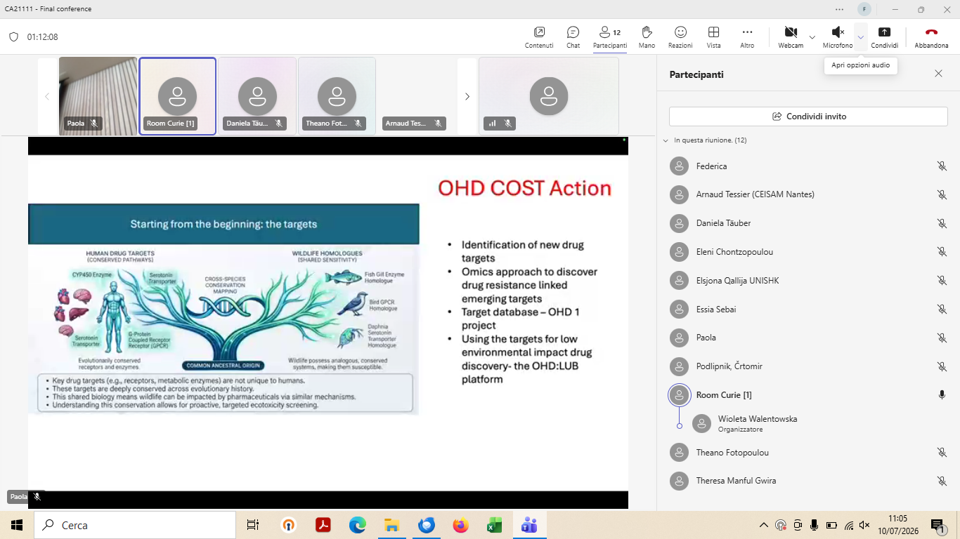

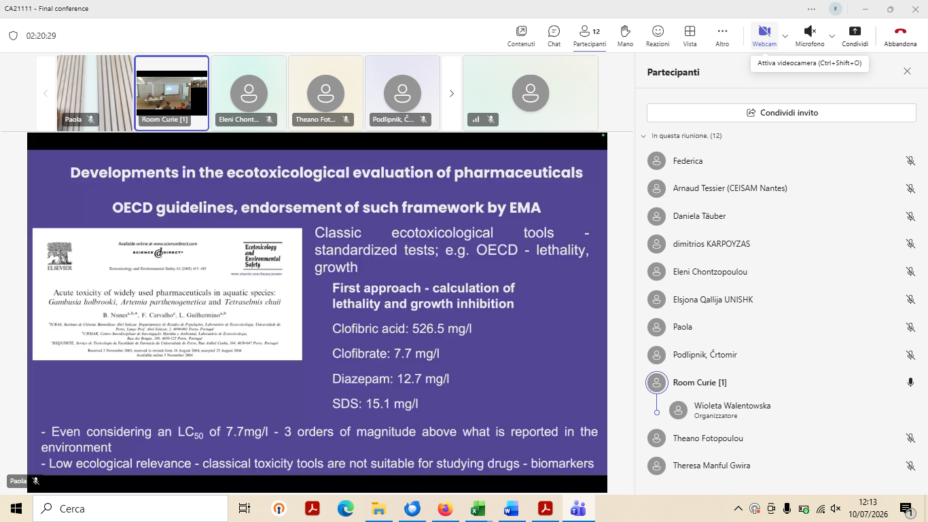

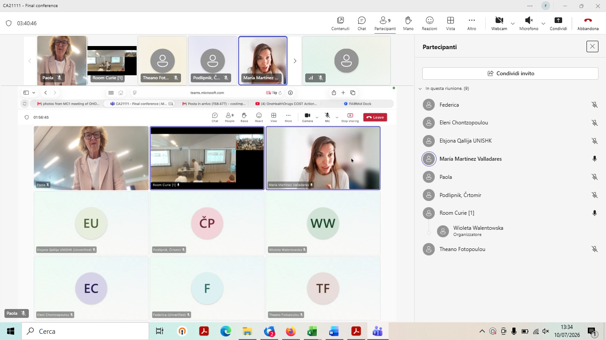

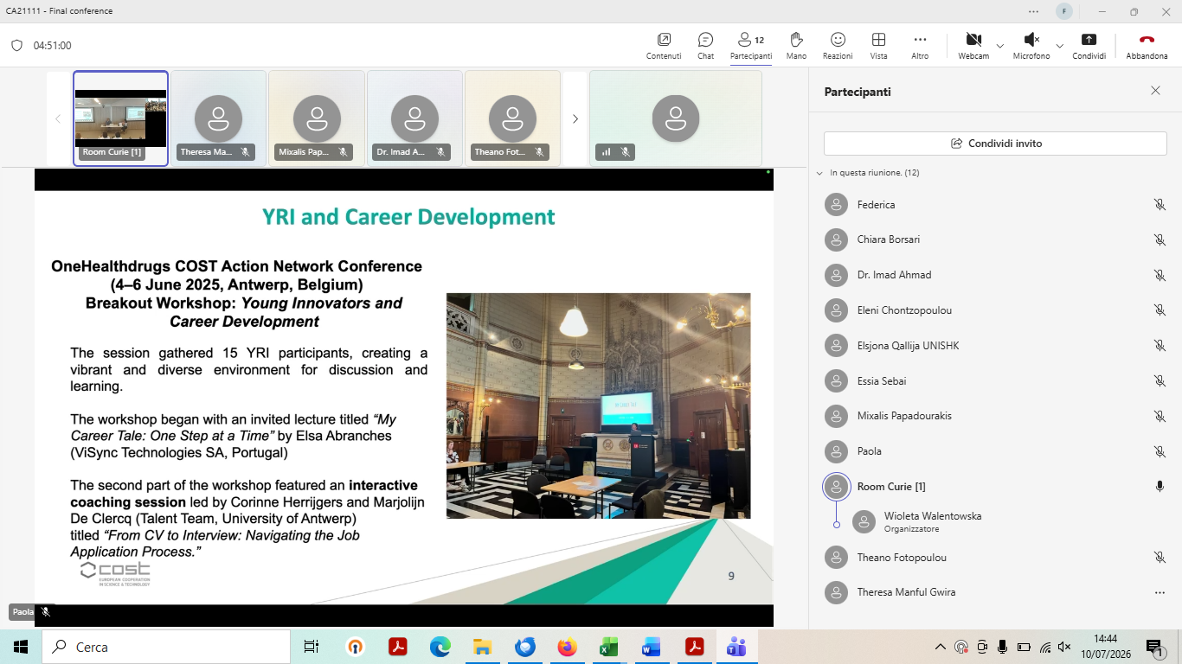

- DESCRIPTION OF THE ACTIVITIES

1. Opening and Objectives
The OneHealthdrugs Forward Look Conference marked the culmination of COST Action CA21111 and was organized to showcase the Action’s scientific achievements, long-term legacy, and future perspectives. The event brought together researchers, regulators, industry representatives, policy stakeholders, and Young Researchers and Innovators (YRIs) to discuss sustainable antiparasitic drug discovery within a One Health framework.
Welcoming remarks were delivered by the COST Scientific Officer and Action Chair, followed by presentations outlining the achievements of the Action, its future roadmap, and the strategic importance of integrating environmental sustainability into antiparasitic drug discovery.

2. Round Table: Scientific Achievements and Legacy
2.1 Integrating Drug Discovery and Ecotoxicology
A central message throughout the meeting was the need to move environmental assessment from a late-stage regulatory exercise to an integral component of drug discovery. Presentations emphasized that environmental safety, human and animal health, and therapeutic efficacy must be considered simultaneously during compound design and prioritization.
The Action demonstrated that ecotoxicological and sustainability parameters can be successfully incorporated into early-stage decision-making through computational tools, predictive modelling, and structured prioritization strategies. The GreenDrugScore concept and related workflows were highlighted as important innovations enabling compound selection based not only on efficacy but also on environmental responsibility.

2.2. Veterinary Survey and Stakeholder Awareness
Results from the multinational veterinary survey highlighted significant knowledge gaps regarding environmental impacts of antiparasitic medicines. The survey collected responses from more than 1,000 veterinarians across 39 countries and explored understanding of One Health concepts, prescribing practices, environmental awareness, and professional training needs.
Discussions emphasized that inadequate awareness during prescribing and use of veterinary medicines may compromise environmental protection efforts. Participants recognised the survey as a valuable evidence base for future educational and policy initiatives.

2.3 Digital Infrastructure and Predictive Platforms
The OHD-LUB initiative showcased the development of computational workflows integrating virtual screening, ADME/Tox assessment, ecotoxicity prediction and sustainability metrics. The creation of the OHD Chemotheca, GreenDrugScore methodologies and related databases was presented as a major scientific output of the Action. These resources provide a reproducible framework for identifying drug candidates with favourable pharmacological and environmental profiles.
Participants acknowledged the strategic importance of FAIR data principles and collaborative digital infrastructures for future antiparasitic drug research.

2.4 Building an Antiparasitic Drug Discovery Pipeline
The OHD antiparasitic pipeline demonstrated how One Health principles can be translated into practical research workflows. The network has generated novel chemical entities, identified new biological targets and mechanisms of action, developed innovative ecotoxicological assessment methods, and promoted alternative preclinical testing strategies aligned with the 3Rs principles.
The Action also contributed to the generation of new environmental toxicity data and fostered collaborations facilitating antiparasitic activity screening and ecotoxicological evaluation across Europe.

2.5. Training, Capacity Building and Young Researchers
The conference highlighted the exceptional contribution of the Action to training and human capacity development. More than 100 young researchers received support through eight international Training Schools covering medicinal chemistry, screening technologies, ecotoxicology, structural biology, natural products, cell-based models and computational approaches.
Horizontal Group 4 activities provided additional opportunities through networking events, mentorship, career development workshops and YRI-focused scientific sessions. Participants agreed that the OHD model represents a successful framework for nurturing the next generation of interdisciplinary scientists.
The YRI success stories presented during the conference demonstrated the Action’s impact on scientific careers, international collaboration and research excellence.

The scientific round table reviewed the main outcomes of the Action and discussed future challenges.
Key messages included:
- Drug discovery for parasitic and vector-borne diseases must benefit both European and global communities, particularly regions disproportionately affected by these diseases.
- Sustainability and ecotoxicological considerations should be embedded throughout the research and development process rather than addressed only at the regulatory stage.
- Scientific advances produced within OneHealthdrugs have demonstrated that environmental risk assessment can be integrated with medicinal chemistry, computational screening and biological evaluation.
- The Action successfully established a collaborative and interdisciplinary network linking parasitology, medicinal chemistry, ecotoxicology, regulatory science and industry expertise.

3. Success stories from Young Researchers and Innovators and OneHealthdrugs Ambassadors
The session “Success Stories from Young Researchers and Innovators and OneHealthdrugs Ambassadors” was one of the most inspiring moments of the conference, highlighting the profound personal and professional impact of COST Action CA21111 on the next generation of scientists. During this session, Elisa Uliassi (University of Bologna), Gulsah Bayraktar (Ege University, Türkiye), Daniele Aiello (University of Modena and Reggio Emilia), Lori Doko (Università degli Studi eCampus), Eli Thorè (University of Namur), and Kayhan Ilbeigi (University of Antwerp) shared their individual experiences and reflected on how their involvement in OneHealthdrugs significantly shaped their scientific careers. [
The speakers described how the Action provided unique opportunities for international networking, interdisciplinary collaboration, mobility, training, and scientific leadership. Participation in the network enabled them to engage with experts from diverse fields, including medicinal chemistry, parasitology, computational biology, ecotoxicology, regulatory sciences, and drug discovery, greatly broadening their scientific perspectives and fostering new research directions.
Among the key competences acquired through their involvement in the Action were:
* Scientific leadership and project coordination skills;
* International networking and collaborative research experience;
* Science communication and dissemination abilities;
* Organization of scientific events, training schools, and workshops;
* Advanced knowledge in sustainable drug discovery and One Health approaches;
* Exposure to innovative computational and experimental methodologies;
* Interdisciplinary problem-solving and teamwork skills;
* Enhanced understanding of environmental sustainability and ecotoxicology in pharmaceutical research.
A common message emerged from all testimonies: OneHealthdrugs was much more than a scientific network. It served as a platform for professional growth, scientific excellence, and personal development. The speakers emphasized that the collaborations established within the Action, the mentorship received, the training opportunities offered, and the exposure to new scientific disciplines had a lasting impact on their careers and future ambitions. Several speakers noted that opportunities created through the Action directly contributed to new research collaborations, publications, funding opportunities, and career advancement. incere gratitude for the opportunities provided by the Action and acknowledged the crucial role that the OneHealthdrugs community played in their development as researchers. The session clearly demonstrated the success of the Action in empowering Young Researchers and Innovators and in building a new generation of scientists equipped to address the challenges of sustainable antiparasitic drug discovery within a One Health framework.
Key Message: The OneHealthdrugs COST Action has created a lasting legacy by investing in young researchers, strengthening their scientific capacities, expanding their international networks, and equipping them with the multidisciplinary skills required to become future leaders in One Health and sustainable drug discovery.

4. Bridging COST Actions OHD and ENVIRANT
Maria Valladares (University of León, Spain) and Dimitrios Karpouzas (University of Thessaly, Greece) presented the synergies between OneHealthdrugs (OHD) and ENVIRANT, highlighting several common interests, particularly in environmental risk assessment, ecotoxicology, sustainability, and the application of One Health principles of the scientific legacy of OneHealthdrugs could continue within ENVIRANT, ensuring that activities related to environmental sustainability, predictive ecotoxicology, stakeholder engagement, and interdisciplinary collaboration are further developed beyond the lifetime of CA21111.
Key Message: ENVIRANT offers a natural framework to build on the achievements of OneHealthdrugs and to continue advancing the integration of environmental sustainability into research and innovation.

5. Position paper from OneHealthdrugs
Theo Zacharis presented the OneHealthdrugs Position Paper, developed through a collaborative process involving researchers, regulators, environmental scientists, and industry representatives. The paper provides guidance on integrating environmental considerations into the early stages of antiparasitic drug discovery while supporting future policy development.
The document is built around four pillars: current practices, environmental evidence, regulatory gaps, and innovative tools for early screening. Its main recommendations include introducing an early environmental screening step, adopting a staged assessment approach, harmonising reporting practices, and promoting Safe-by-Design principles through funding mechanisms.
Key Message: Environmental sustainability should be considered early in drug discovery to support the development of safer and more sustainable medicines without compromising innovation.

6. Round Table: Industry and Regulatory Perspectives – “Steps Forward”
Moderated by Sheraz Gul, the second round table brought together representatives from industry, regulators and professional organizations to discuss implementation challenges and future opportunities.

Main Discussion Points
6.1 Environmental Assessment Must Start Earlier
Participants agreed that environmental risks are much more difficult to address after product approval than during early development. Greater integration of ecotoxicological assessment into discovery pipelines was considered essential.

6.2 Recognition of Sector Differences
It was emphasized that human pharmaceuticals, veterinary medicines and crop protection products operate under different scientific, regulatory and commercial realities. Future policies should acknowledge these differences and avoid oversimplified approaches.

6.3 Market Forces and Adoption Barriers
The discussion highlighted that prescribing choices are often driven by cost, availability and convenience rather than environmental performance. Consequently, environmentally preferable alternatives may require many years to achieve widespread adoption.

6.4 Proportional and Science-Based Regulation
Industry representatives stressed the importance of proportionality when introducing additional environmental testing requirements. Regulators acknowledged these concerns while emphasizing the need to apply accumulated scientific evidence and reassess decisions when new information becomes available.

6.5 Innovation and Artificial Intelligence
Participants recognised the potential of computational models and artificial intelligence platforms to support safer drug development and environmental risk prediction. There was broad agreement that new methodologies should be evaluated on scientific merit and integrated gradually into accepted regulatory frameworks.

6.6 Education as a Strategic Priority
A recurring theme was the lack of sustainability and ecotoxicology training in most health and life sciences curricula. Participants strongly supported earlier integration of these topics into university education and professional development programmes.

7. Key Outcomes
The conference identified the following major achievements of COST Action CA21111:
- Establishment of a European interdisciplinary network connecting drug discovery, parasitology, ecotoxicology, regulatory science and industry.
- Development of innovative computational tools and databases enabling sustainability-oriented antiparasitic drug discovery.
- Generation of scientific evidence supporting early integration of environmental safety assessments into pharmaceutical research pipelines.
- Creation of significant training opportunities and career development pathways for Young Researchers and Innovators.
- Production of stakeholder-informed recommendations through engagement with academia, industry and regulatory communities.

8. Recommendations and Future Actions
Participants agreed on several priorities for the post-Action phase:
- Continue development and dissemination of the OneHealthdrugs Position Paper.
- Strengthen collaboration with related initiatives, including ENVIRANT and other European sustainability-focused networks.
- Promote the integration of ecotoxicological assessment and sustainability metrics into early drug discovery workflows.
- Expand educational programmes addressing One Health, sustainability and environmental pharmacology.
- Support implementation and regulatory acceptance of innovative predictive methodologies, including AI-assisted approaches.
- Maintain the OneHealthdrugs network as a platform for future collaborative projects and funding initiatives.
- Ensure continued support for young researchers through training, mobility and networking opportunities.

9. Closing Remarks
The conference concluded that COST Action CA21111 has successfully demonstrated the feasibility and value of integrating One Health and sustainability principles into antiparasitic drug discovery. Participants identified a strong consensus among academia, industry and regulators that environmental responsibility must become an integral part of future pharmaceutical innovation. The Action leaves a lasting legacy through its scientific outputs, collaborative network, digital resources, training activities and policy-oriented recommendations, providing a foundation for safer and more sustainable medicines in Europe and beyond.

- ANNEXES
Abstract Book: https://drive.google.com/drive/folders/1mgs2KBWhiaUp-YP4Aj9OeaZToSjYWbzh
Presentations: https://drive.google.com/drive/shared-with-me

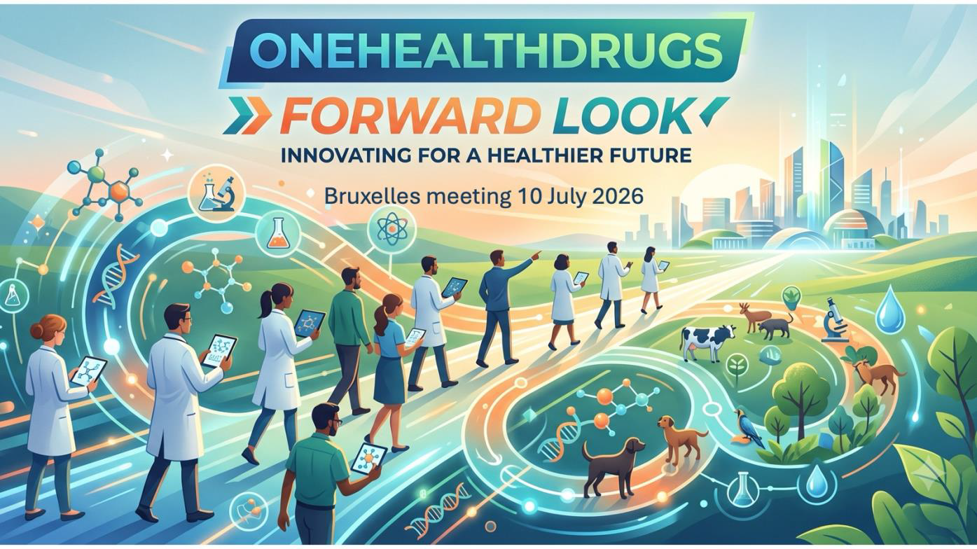

Youtube
https://youtu.be/BBzIVanwc5U

