AGENDA ONLINE WORKSHOP
“Protein Degradation as a cutting-edge approach in drug discovery”
(Co-organized by WG2 and HG4)
October 9, 2026, from 1:30 pm to 3:30 pm CET

This interdisciplinary workshop will provide a state-of-the-art overview the workshop will explore PROTACs and targeted protein degradation as innovative strategies relevant to drug discovery.

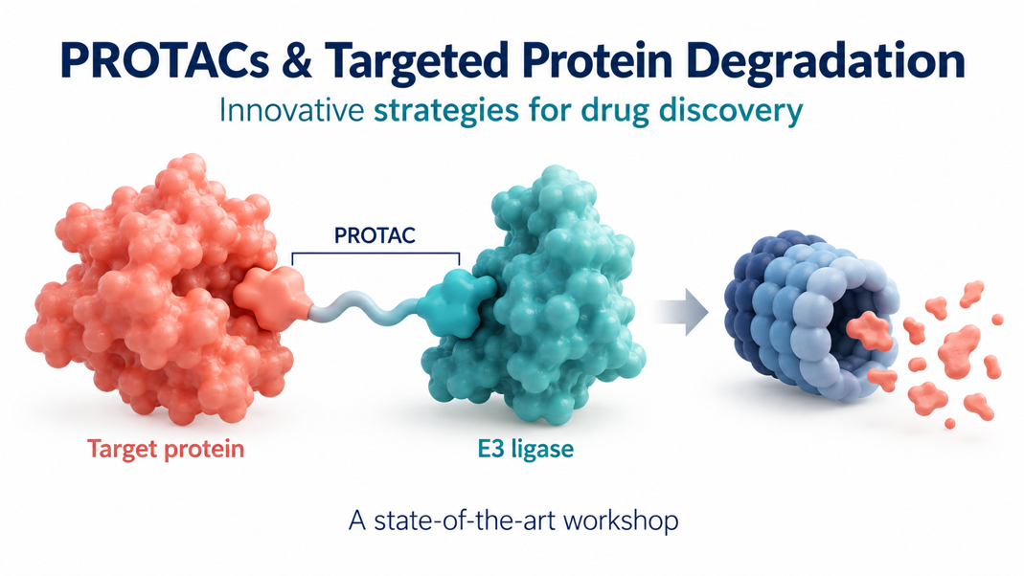
TEAMS LINK
“Interdisciplinary Workshop on PROTACs” Co-organized by WG2 and HG4) October 9, 2026, Partecipazione alla riunione | Microsoft Teams

October 9, 2026, from 1.30 pm to 3.30 pm CET

1:30 – 1:40 Welcome and introduction

1:40 – 2:05 Dr. Niki Chondrogianni - National Hellenic Research Foundation, Athens, Greece
The proteasome function and implication in diseases

2:05 – 2:30 Dr. Cécile Exertier - CNR - Institute of Molecular Biology and Pathology, Rome, Italy
Hijacking Leishmania’s ubiquitin-proteasome system through structure-guided PROTAC design

2:30 – 2:55 Prof. Eleonora Diamanti - University of Verona, Italy
Use of PROTACs for the treatment of Flavivirus infections

2:55 – 3:20 Prof. Andrea Milelli - Department of Pharmacy and Biotechnology, University of Bologna
Targeted Protein Degradation: New Perspectives in Neurodegeneration

3:20 – 3:30 Open discussion and reflections, conclusions and way forward

Organized by Elisa Uliassi (IT, HG4 Leader), Theodora Calogeropoulou (GR, WG2 leader), Maria Paola Costi (Action Chair), Anabela Cordeiro Silva (Action Vice-Chair)

